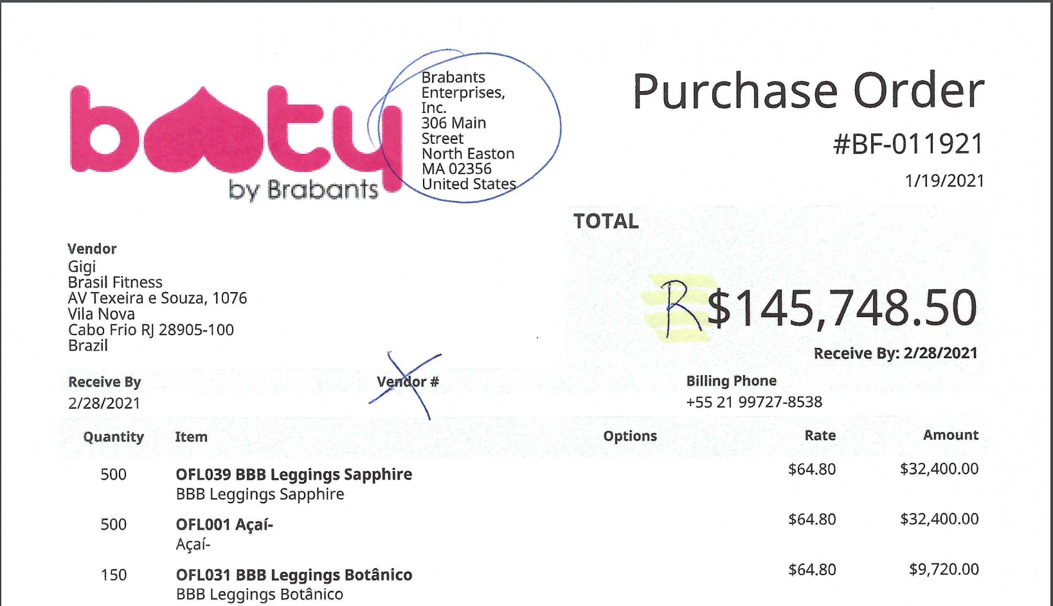

* Remove the Vendor # field and move the Vendor with address detail to the right.
* Move the Brabants Name and Address under the Logo where the Vendor details are now.
* Reduce the font of the words Purchase Order in the top right.
* Reduce the font size of the ‘Total’ section and format for Brazilian Real currency (R$ ).
* Remove the Receive By value under the Amount.
* Remove the Options column.

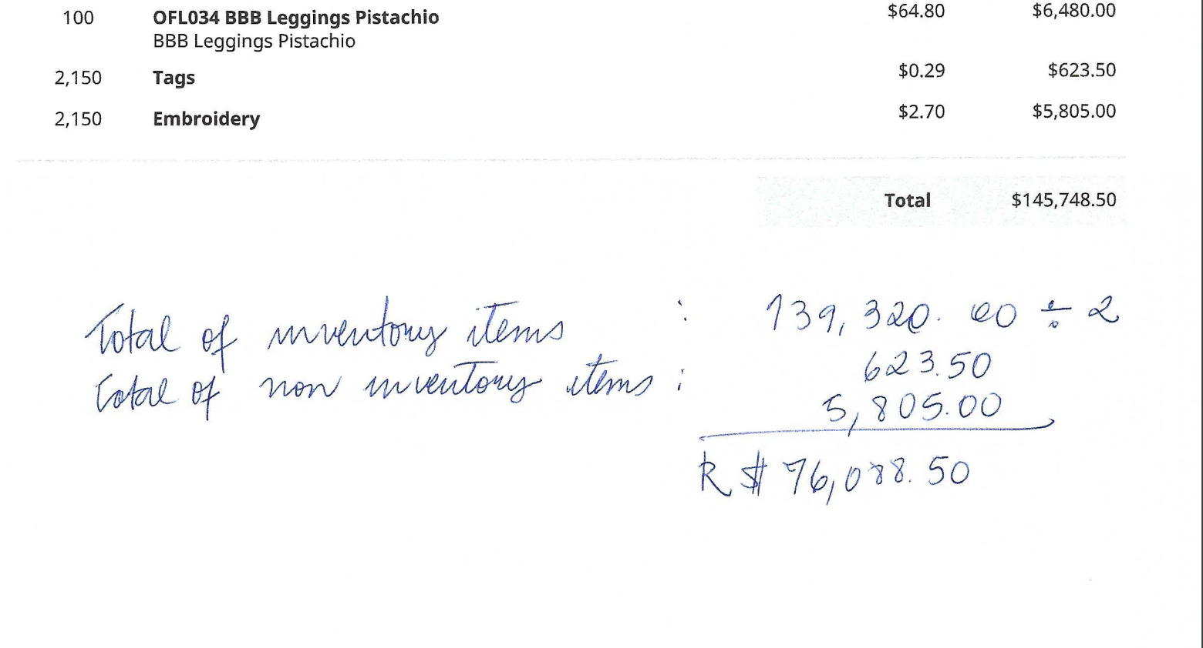

For the bottom of the PO I have created some additional fields on the purchase order form (see below). These will require calculations to be done and then print on the PO PDF.

There is a field grouping on the purchase order titled PO Breakdown.

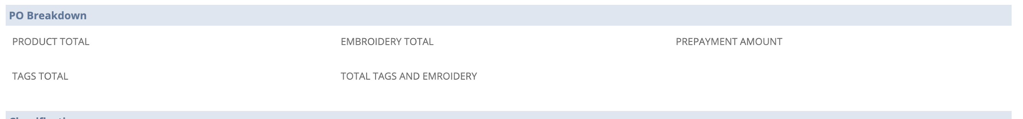

On the purchase order there will be ‘Inventory Items’ and ‘non-inventory items’.

* Product Total: This field should include the total of all the Inventory Items listed on the purchase order. Field ID is custbody_bbb_product_total
* Tags Total: There are non-inventory lines on the purchase order for Tags. This field should include the total of all Tag lines on the purchase order. The item ID for the Tag item in Sandbox is 2524. The Field ID is custbody_bbb_total_tags
* Embroidery: There are non-inventory lines on the purchase order for Embroidery. This field should include the total of all Embroidery lines on the purchase order. The item ID for the Embroidery item in Sandbox is 2525. The Field ID is custbody_bbb_embroidery_total
* Total Tags and Embroidery: This field should include the total of Tags and Embroidery for the purchase order. Field ID is custbody_bbb_total_tag_emb
* Prepayment Amount: This is a calculated field that needs to be paid to the vendor. The calculation is ‘total tags and embroidery’ + (product total/2). Field ID is custbody_bbb_prepayment_amount

For the lower half of the PO PDF they would like to have a section titled PrePayment with details as follows:

* 50% Sinal: This would be the Product Total divided by 2.
* Inside Tags: Value from the Tags Total field including Unit Price from PO line.
* Embroidery: Value from the Embroidery Total field including Unit Price from PO line.
* Payment Authorized: Total from the Prepayment Field.

